**GAME CROSSING ROAD REPORT**

-Uml diagram: 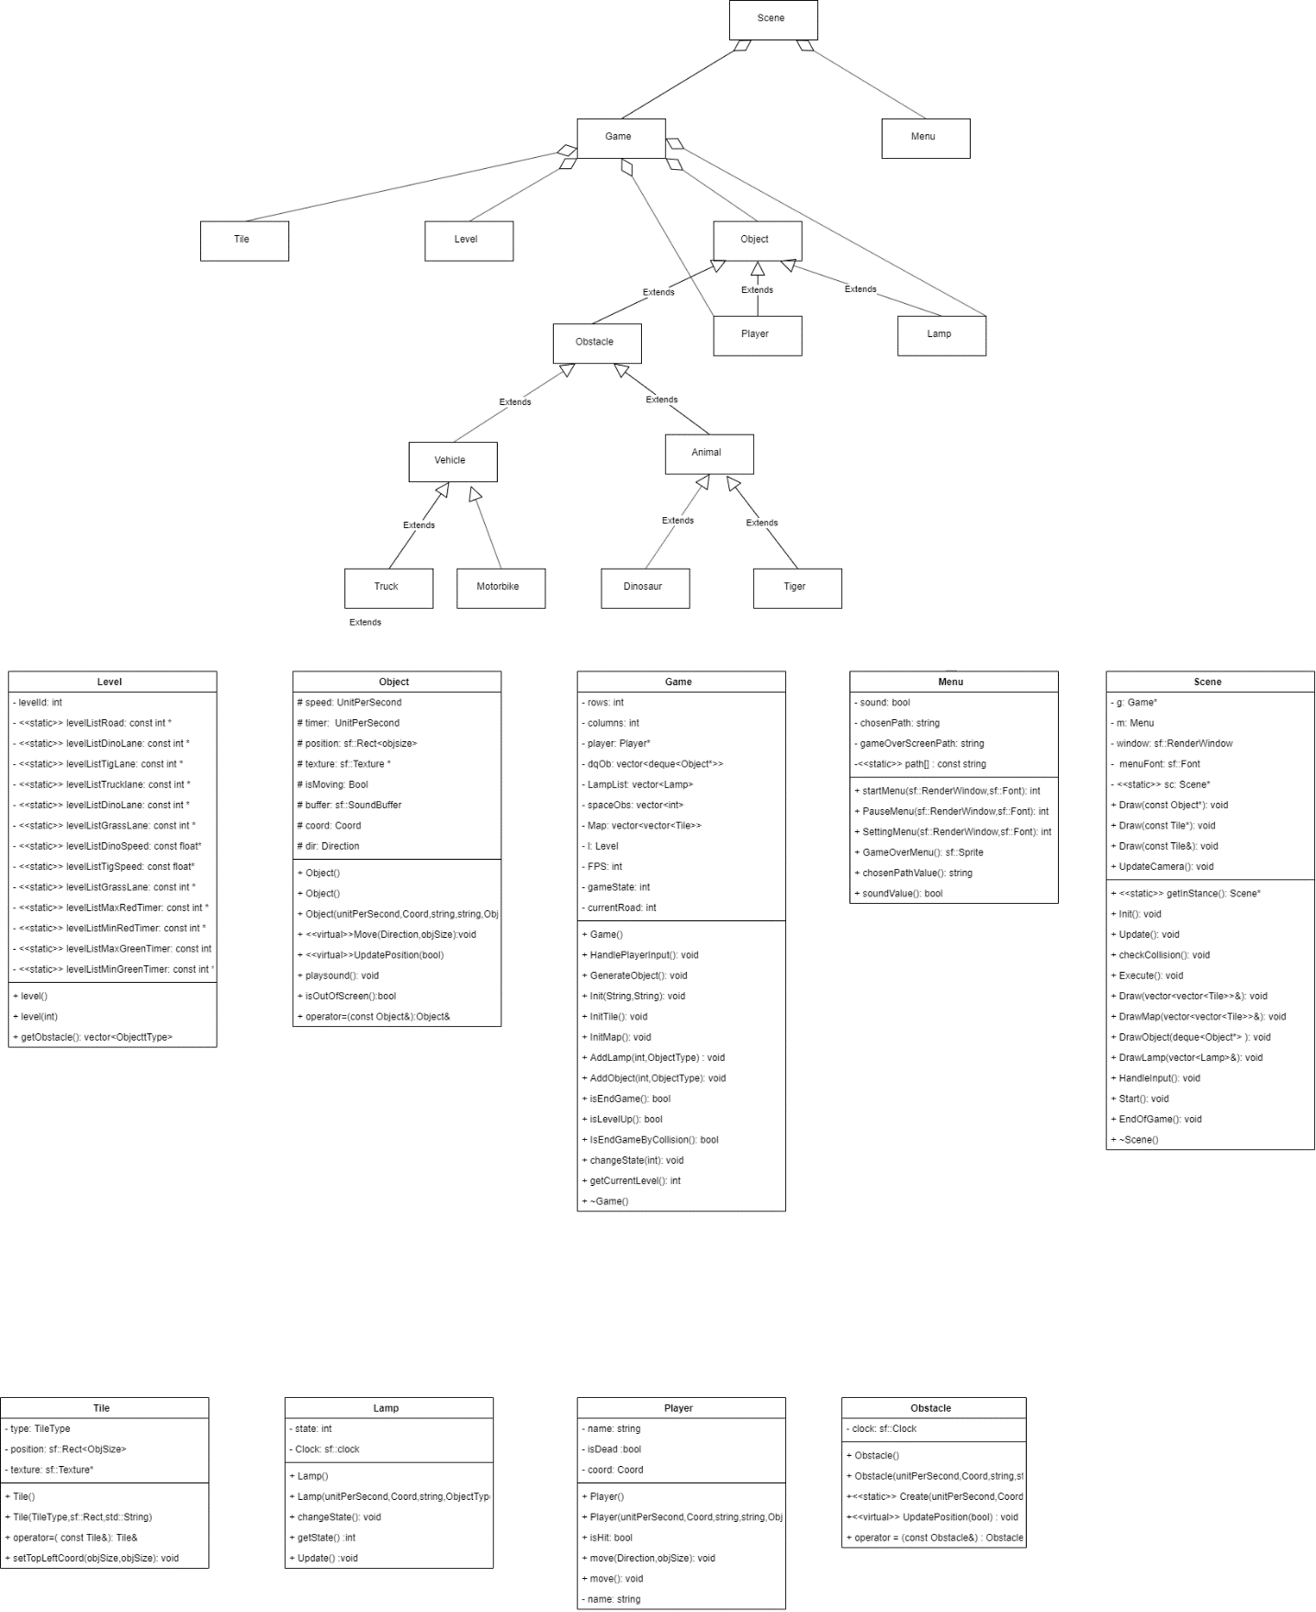

-Features of the app:

+Users can load exist game or start a new game or save the level of the current game they are playing.

+Our app allows users to switch between skins or turn on/off sound arbitrarily.

+Pause menu, game over screen, graphic.

+Currently ,ours game has 5 levels but we can upgrade it if needed.

-Gameplay:

+Players have to move their character through a bunch obstacles ( dinosaur, tiger, car, truck…) without get hit by one of them.

+Players is allowed to go to the next level if they can surpass all the obstacles and touch the finish line.

+The speed and number of each type of obstacle is not the same.

+The obstacles will stop if the lamp in their lane change to red, they can move again after the lamp change back to green. Players should make use of this to finish that level easier.

+User will achieve a final win if they can pass the max

Level.

-Design/architecture of ours app:

+The object scene is responsible for manipulating the

operation of the app( Menu, render, handle

Inputs, events, collisions ,level up…)

+Class game will take charge of the initialize of

obstacles, lamps, players. It also stores and updates

their positions as the game going on.

+Player , obstacle , tile inherit from the object

class.

+Dinosaur, tiger, car… then inherit obstacle class.

+Class level will decide the difficult of the game base

on the current level.

+Menu class contains options which are start game,

load game, setting, exit.

-Difficult in the project ‘s implementation process:

+We have many choices of graphic libraries. Each has different advantages and disadvantages.

+We have to change the design of ours project several times due to the problem which we are not aware of when define the architecture.